

It’s More Than Just a Porta Potty: Development of the Revolutionary Smart Portable Toilet

Group Number 10

Ahmed El-Mouwfi

Curtis Fetteroll

Logan Miller

Randall Louie

Prof. Craig Calvert

Prof. Frank Cunha

Sponsor: Rick Davids

In Collaboration with Civil/Environmental and Electrical Engineering Departments





**Table of Contents**

Section 1: Executive Summary 4

Section 2: Project Introduction 4

Technical Review 6

Section 3: Problem Definition 6

A. Stake Holders 6

B. Scope 6

C. Service Environment 6

D. Previous Work 6

E. Deliverable Requirements 7

Section 4: Design Description 7

Section 5: Design Evaluation 10

Section 6: Design Recommendations 12

A. Currently Recommended Design 12

B. Future Design Requirements 12

Business Plan 14

Section 7: Company Overview 14

A. Company Introduction 14

B. Technology 14

C. Product/Service 14

D. Intellectual Property Status 14

E. Commercialization Strategy 15

Section 8: Industry Overview 16

A. Industry Definition and Description 16

B. Regulations and Policies Driving the Industry 16

Section 9: Customers 17

A. Customers & End-user 17

B. Buying Behavior 17

Section 10: Market 18

A. Market Definition 18

● Primary market 18

● Secondary markets 18

B. Primary Market 18

● Predicted annual growth rate 18

Section 11: Competitors 19

A. Indirect Competitors 19

B. Direct Competitors 19

C. SWOT Analysis 19

Section 12: Marketing and Sales Plan 20

A. Opportunity Statement 20

B. Marketing & Sales Objectives 20

C. Current Customers 21

D. Potential Customers 21

E. Pricing 21

F. Sales Plan 22

G. Advertising 25

H. Sales/Marketing Budget 26

Section 13: Research and Development (R&D) Plan 27

A. ~~R&D Objectives~~ 27

B. ~~Milestones and current status~~ 27

C. ~~Technical Risks~~ 27

D. ~~Staffing~~ 27

E. ~~R&D Budget~~ 27

Section 14: Manufacturing and Engineering (M&E) Plan 28

A. Objectives 28

B. Staffing 29

C. Manufacturing/Engineering Budget 30

D. Quality Control 33

Section 15: Human Resource Plan 33

A. Staffing Objectives 33

B. Organizational Structure 35

C. Human Resource Budget 35

Section 16: Risk Management Plan 36

A. Potential Risks 36

Section 17: Financials 38

A. Financial Objectives 38

B. Plans for obtaining investors or strategic alliance 38

C. Pro Forma Profit & Loss statements 38

D. Pro Forma Cash Flow projections 39

E. Pro Forma Balance Sheet 39

F. Alternative return scenarios 39

Section 18: Appendices 40

A. LooLoo Virtual Model 40

B. LooLoo Full-Scale Prototype 40

C. LooLoo Instruction Manual 44

D. RACI Matrix 45

E. Appendix Title 45

Section 19: References 45

**Table of Figures/Tables/Images/Illustrations**

Table 1: Sample Table 4

# Executive Summary

This report compiles all of the information relevant to the LooLoo senior design project, regarding both the technical and business aspects. This interdisciplinary project aims to develop a revolutionary portable toilet unlike anything already on the market. It will have a modular design that is easy to assemble and includes features such as waste management and solar powered device charging capabilities. The goal is to work with organizations already in the humanitarian aid sector to help those communities in need, specifically the homeless and disaster-affected or developing communities. These communities often struggle to accommodate their members’ needs for a place to safely go to the bathroom, a privilege many people take for granted. This often causes health risks to develop due to open defecation in public facilities and water sources. The design process in this project consisted of an iterative cycle of providing requirements, researching and presenting design solutions, reviewing those proposed designs, providing feedback, and repeating. Through this process the structural materials were narrowed down to those with the greatest balance of cost, weight, strength, and environmental resilience. The electrical components have been evaluated and modified multiple times to achieve an optimal design for power storage and output, while minimizing the cost. The waste management system minimizes bad odors while allowing for efficient storage and removal of the waste. The business plan will lay out the marketing plan, distribution plan, and manufacturing plan. All of these elements will be further explored and elaborated on in this report.

# Project Introduction

This senior design project is sponsored by Rick Davids, a retired human factors engineer. The goal of this project was to produce a portable utility to aid the homeless population and those in developing communities in order to alleviate the obstacles to normal bathroom functions. This utility will also provide these people with the ability to charge their devices. This document will lay out the many facets of this project regarding both the technical and business aspects.

There is no doubt a need for safe and accessible toilet utilities. The amount of homeless people in the United States of America alone is staggering and the need only becomes more clear as one begins to branch out into other areas of the world. Many of the developing countries have a lack of resources and a lack of facilities to be used. In these areas and in the homeless communities, open defecation is a major sanitation and health issue, as it often leads to contaminated surfaces and unsafe drinking water. This also leads to an economic burden on those authorities tasked with remedying this problem. There are many non-governmental agencies that focus on the issues of homelessness and humanitarian aid, but these issues still prevail. The hope for this project is to sell the product, or production plans, to these types of organizations or even partner with some of these organizations to take our product to market. Our utility would provide a solution to the public health issue taking place by providing what many take for granted, a toilet that is safe and accessible. This would come with the added benefit of providing electricity for these people to charge their phones right at the same place. Even though these communities may not have much, most people still have a phone they need to charge.

The product itself will be modular, being assembled, purchased and shipped in its 3 major subsystems. These include the toilet structure, the waste management system, and the electrical power cap. It will be easy to set up, requiring minimal time, tools and knowledge. The structure will be able to withstand the loads associated with a typical toilet experience and also the weather conditions of many different geographical locations. The waste management system will collect and separate the waste using a urine diversion method to aid in waste removal and recycling, as well as smell mitigation. The electrical power cap consists of a solar power, battery, inverter, and other electrical components to power the charging capabilities and lighting. A virtual model and a full-scale model were developed and tested to demonstrate the feasibility of the final design. A detailed business plan was developed, including a marketing plan, distribution plan, manufacturing plan, and relevant cost/benefit analysis. This interdisciplinary project was worked on by 3 different engineering department teams. The Management and Engineering for Manufacturing team has the systems engineering and business roles, while the Civil & Environmental Engineering team and the Electrical & Computer Engineering team took on the design team responsibilities. Team communication was absolutely crucial in successful project completion as the systems engineering team led the design teams to create a final product that interfaced well with the electrical, structural, mechanical, environmental, and business requirements.

#### Technical Review

# Problem Definition

## Stake Holders

There were several stakeholders involved in this project. Our project sponsor, Rick Davids, has a vested interest and would be considered the main stakeholder. He has invested his time, money, and ideas to support the success of the project. The MEM team along with the civil and electrical engineering teams are stakeholders as well. We were responsible for carrying out the project and creating something that Rick was satisfied with. Lastly, the MEM, CEE, and ECE advisors monitored our progress and ensured that the students were adding value for the sponsor.

## Scope

The goal of the project was to create a small-scale model of the portable toilet, but this scope was extended by developing a full-scale prototype instead. In order to do that, we had to design and test a virtual model with SolidWorks. The product needed to be structurally sound and able to withstand harsh weather conditions. It also needed to have lighting and charging capabilities through the use of a solar panel. In addition, the product had to be easy to assemble and transport. The scope of the project also included the creation of a detailed business, manufacturing, and distribution plan. These plans were meant to support the introduction of a new product like ours.

## Service Environment

The utility will be installed in areas of need and/or weather damaged areas. Distribution to these areas will be done in collaboration with non-governmental organizations such as the International Medical Corps. They will bring the experience and funding to ship our product to the end user. Also, the design of our utility is modular so it will be packaged and shipped as 3 different subsystems. This allows the customer the option to purchase only the pieces they need or want. For example, they may choose to purchase only the structure and the waste management system and save money by not purchasing the electrical system and charging station. However, all three subsystems will be pre-processed and easily put together.

## Previous Work

We are working to create a product that is similar to a porta potty. Therefore, previous work has been done that will aid in our project. The first portable toilet was used in World War II for ship crews that spent a long time out at sea. The first iterations of them were made of wood and metal. Because of this, they were more difficult to move and empty. Then they switched to polyethylene plastic to create a lighter, more resilient, and easier to set up restroom. Also, the first porta potties used formaldehyde-based deodorizers to mask the smell. Later on, they switched to non-formaldehyde deodorizers because local wastewater treatment plants could not process them. The blue liquid in porta potties today contain biocides that inhibit the growth of odor-producing bacteria. These considerations were important for the design of our portable toilet, especially considering that one of our biggest design requirements was creating a lightweight, easy to set up utility. We have also found previous work done in regards to implementing restrooms in areas of need. Sanivation is an East African company that installs container based toilets in homes for free, but then charges a fee to service them once a week. Because we are looking to bring our product to homeless or damaged areas, Sanivation has given us insight into that process.

## Deliverable Requirements

The wall structure of the toilet needs to be light enough so that it can be easily carried by two people. It also needs to be weather resistant and strong enough to support the electrical components. Only using wood would be too heavy and not rain resistant, metal is too heavy and expensive, and plastic is not strong enough. Initially corrugated polycarbonate was chosen for the wall material, due to all of these concerns. At the end of the project, the teams decided on hardboard plywood siding, which is lighter than standard wood and much more weather resistant. The utility also needed to have an effective waste management system that can be removed easily and contain the smell. A urine diversion system will separate the liquids and solids for easy disposal and smell control. There will also be a solar panel mounted on the roof along with a charge controller, battery, and inverter so that a charging outlet can be installed inside of the structure. The outlet will be connected in a parallel circuit with the lighting system. This will allow for the removal or replacement of one of those components if it is necessary.

# Design Description

Due to the nature of this project, our design process followed that of the new product development process. An example illustration of this process is shown below.

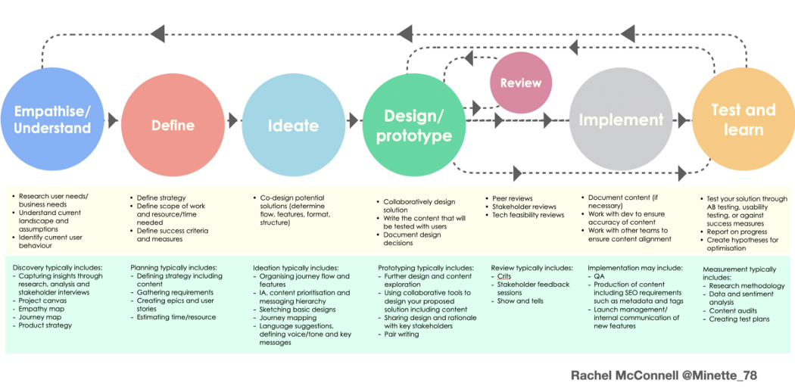

Figure 1: Product Development Process Flowchart

Our process began with understanding the customer needs for this product. Our sponsor explained to us the severity of homelessness in our country and the often unacknowledged health risk of open defecation in communities around the world. Many people lack access to safe toilet facilities and thus have no choice but to take care of their business on public grounds or even in public water sources. The demand for a product that would provide some assistance to these people in need quickly became abundantly clear to the team. The problem was defined and the project quickly moved into the ideate phase. The sponsor already had many ideas upon initiating this project and the system engineers took these ideas on how to solve this problem and defined them as particular requirements which needed to be met by the product design. This product needed to solve these problems by providing an easy to assemble and structurally sound portable toilet with sufficient environmental protections, a waste management system that could separate liquids from solids, and an electronics subassembly that would provide device charging capabilities through solar power. At the same time as the sponsor’s ideas were being translated into requirements, the teams involved also began coming up with their own ideas on how to solve this problem and started their research on fulfilling the project requirements.

The next two steps are where the teams spent most of their time in this project. The design/prototype phase and the review phase have been repeated multiple times. In the design phase the design teams researched and analyzed the many possible solutions to the problems they were presented with and had to perform certain trade-off studies in order to decide what options were best suited for this project. The systems engineering team hosted a preliminary design review in which the design teams presented their progress up to that date and their proposed design solutions. These were reviewed and then feedback was provided to them on what aspects of the design were acceptable and which ones still needed work. After this first design review it was clear that the many different components of the product were causing the teams to run wild and lose focus. One of the main objectives following this review was to focus on the absolute necessities of the design before looking into any potentially optional additives. This included finding structural materials which were cost effective and had a good balance between strength, weight, and environmental protection. The waste management system needed to be further developed as well as the layout of the toilet. The electronic components were well researched and it was clear that some components could be replaced with alternative options or removed completely, such as a sanitation system. This feedback is what drove the design teams in their return to the design phase which they worked on until the secondary design review. In this design review, once again hosted by the systems engineering team, the design teams showed significant progress. The structural analysis was much more complete and some materials were proposed. The waste management system had a finalized design and involved a urine diversion process that separated the fluid waste from solid waste, allowing for easy removal and recycling of different waste products and also minimized the unpleasant odor that is so unappealing in most toilets. The electrical analysis of power consumption showed that the proposed combination of solar panel, battery, inverter, and other components was very feasible and the toilet likely would never lack the power necessary to perform those functions. The figure below shows the different aspects of each subsystem in the modular design proposed at the second design review.

Figure 2: LooLoo Subsystem Breakdown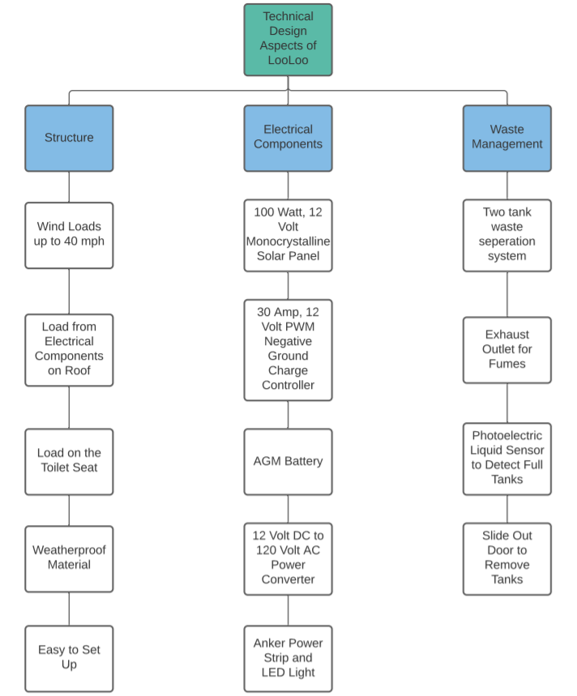

Following the second design review, there were still some design changes that needed to be made. The materials proposed by the design teams for the structure did not seem feasible based on the systems engineering team’s analysis so it was recommended to look into some more practical alternatives. The estimated cost was also too high for this product to be competitive so it was recommended that the teams cut costs in any way possible, so long as it was safe for the design of the product and would not cause it to no longer meet requirements. Thus, the teams moved back into the design/prototyping phase. The plan was to have the design finalized prior to the Spring semester starting. In order to confirm this, the design teams’ work needed to be reviewed repeatedly until requirements were sufficiently met. However, there was communication with a design contact at International Medical Corps, an outside organization, to help tailor the product to certain areas of the world. The systems engineering team analyzed all of the communications done over the 2 month break, cross-referenced those changes with the design iteration from the secondary design review, and suggested the most viable solution to the sponsor. The team was able to propose new design requirements which allowed the teams to continue the work that was started earlier in the project, appease the concerns brought to light by IMC, and minimize the complexity of the product design. After the design teams had time to work on what was deemed necessary and eliminate those components which were not, the final design review was held. The result was a finalized system design which encompasses all of the components in Figure 2, except the waste detection system which was deemed unnecessary.

Following approval from this design review, the teams began drafting the SolidWorks model and doing further mathematical testing for the design. These types of theoretical testing included load analysis, power output, efficiency, and more. This brought the teams into the “test and learn” phase as well. Implementation is the only phase not met by this project, but the project was left in a place in which it can easily be implemented by the sponsor.

# Design Evaluation

As mentioned in Section 4, the new product development process is highly iterative. Changes are continually being made early on in the project lifecycle, with this process eventually narrowing down to a final design. This narrowing process involves repeated design/review/feedback loops that eliminate certain design possibilities and promote others. For this product, one of the most important aspects was the material selection for the structure. Because this one design aspect can cause failure of the entire system, a lot of consideration had to go into which material to use. The material needed to be light enough to meet the requirement of being easy to set up and to make the shipment/assembly process easier. It needed to be strong enough to bear the loads of the person using the toilet, the waste management system itself, the electronics system, and any loads due to weather conditions such as wind or snow. At the same time as meeting these requirements, the material selection was further constrained by the cost of the material. It needed to be cheap enough that the price of the final product could remain affordable and competitive in the market. A weighted factor analysis was performed for 4 different materials and is shown below. The first step in this process was defining the selection criteria, which were determined to be cost, strength, weight, weather, and appearance, defined by the definitions in Table 1. This table also shows what each rating means for each of the criteria and assigns a weighting factor to each criteria. It can be seen that cost was the most important factor, followed by strength and weather, then weight, and finally the appearance as the lowest priority. The 4 materials analyzed were wood, plastic, metal, and corrugated polycarbonate, a composite material. Table 2 shows the breakdown of each of these materials rated across each of the selection criteria. The weights assigned to each criteria were then applied across each material’s ratings in order to produce the results shown in Table 3. Corrugated polycarbonate was shown to be the best material out of these choices as it excelled above the others in nearly every category. Thus it was recommended to the design teams to consider this and other composite materials that would be most effective in accomplishing the design requirements set forth. Similar analysis was completed for other aspects of the design. The final design ended up switching the materials again, choosing a hardboard plywood siding instead of the polycarbonate as it met the requirements better. A power consumption analysis was completed for the electrical subsystem. This study, shown in Table 4, estimated that the system would consume 79.5 Watt-hours each day. It was conservatively estimated that the solar panels would be able to collect somewhere between 198 and 234 Watt-hours each day, meaning there is still plenty of excess power to be used. It was also analyzed that the battery can be fully charged by the solar panel in about six and a half hours and can store enough energy to power the system for about two and a half days. Thus this system is extremely reliable and it would be able to handle days in which more phones need to be charged or days with poor weather conditions that don’t contribute as much solar energy.

|  |  |
| --- | --- |
| **Device** | **Estimated Daily Power Usage** |
| Lighting System (2 Watts/Hour/LED Strip) | 48 Watt-hours |
| Charging Station (Three Devices Fully Charged) | 31.5 Watt-hours |
| External Lighting System (Independent Power Source) | 0 Watt-hours |
| **Total:** | **79.5 Watt-hours** |

Table 4: Electrical Subsystem Power Consumption

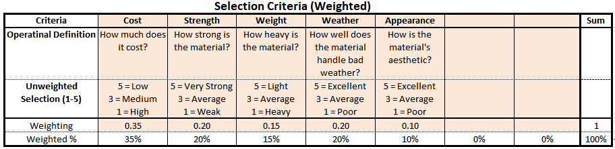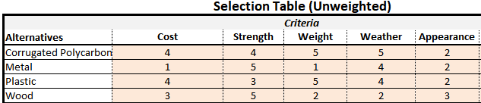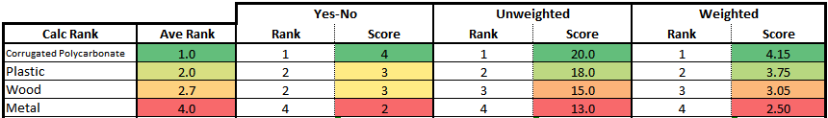

# Design Recommendations

## Currently Recommended Design

We recommend that the structure is built out of hardboard plywood siding for the walls, since it is comparable to corrugated polycarbonate but with better strength properties. The polycarbonate material would have required some structural reinforcement as this material is flimsy and only has exceptional strength with spaced out reinforcements. The waste system should consist of two separate collection tanks, one for liquids and one for solids, in order to provide easy removal of the different waste products and to mitigate the typical smell associated with portable toilets. Urine diversion should be designed in a way that it routes the liquid waste into its own container without allowing the solid waste through, using a funnel system. The electronic components should be composed according to the layout in Figure 3, which shows the proposed electrical schematic setup. This design with the different electronic systems being connected in parallel would allow for any of them to be removed without affecting the other components. This is set up in a way to minimize the risk of one small failure causing total failure of the electrical system. Appendix A contains pictures of the virtual model and Appendix B contains pictures of the full-scale prototype, including the structure and the electrical subsystem.

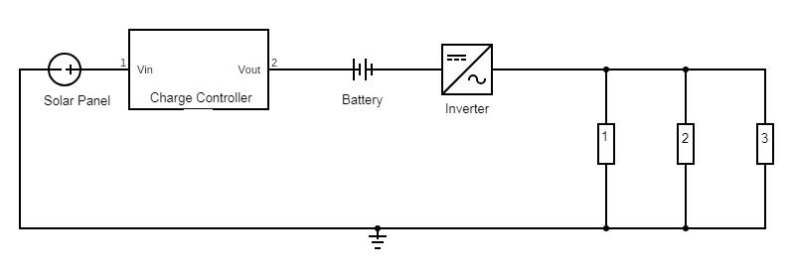

Figure 3: Electrical Subsystem Diagram

## Future Design Requirements

As is, this product could be implemented into the real-world market as a functional utility. However, there are some design considerations that could be taken into account in the future development of this product. First of all, because many of the materials are commercial-off-the-shelf items, it is important to consistently re-evaluate the options on the market in case there are better alternatives to what has been decided at the time of this project being completed. Second, the teams decided to reduce the complexity of the product by eliminating some functionalities which were deemed out of scope. If this product was further developed, however, these additions would only increase the value added relative to competitors on the market. One of these was part of the waste management system and consisted of a sensor in the waste containment which would monitor the waste levels and use a Raspberry Pi system to alert the concerned parties of when it would be necessary to remove the waste. This increases efficiency, functionality and safety of the system. Another option that was removed was a ventilation system as part of the electronics package. It was deemed unnecessary since the urine diversion system already eliminates most of the undesirable odor. The current design uses natural ventilation created by air flow through the structure, but a small fan powered by the solar panel would increase the effectiveness of the ventilation within the system. Further communication could also be done with the contact at IMC in order to ensure that LooLoo meets practical and social requirements in the areas where this product would be implemented.

#### Business Plan

# Company Overview

## Company Introduction

The project sponsor, Rick Davids, is not part of a formal company. He has been working independently for several years sponsoring numerous capstone design projects. However, he was still able to provide the team with adequate funding and knowledge of the product and design process. His mission is to create a utility that can provide a unique relief to underprivileged or damaged areas of the world while also leading a group of students to succeed.

The project team was also looking to reach out to Sanivation, a company that installs container based toilets at homes in secondary cities in East Africa. Although they are not a sponsor, it will be helpful to learn from a company that has a similar mission. In 2016 the company was recycling about 10 tons of waste per month from their toilets. Their experience/expertise is something this project was loosely modeled on. The same goes for International Medical Corps, a company which the team contacted and collaborated with to meet the practical and social requirements of the target markets.

## Technology

The company/Rick could not provide any physical resources besides funding and guidance. Therefore, besides the technology provided through UConn, our project did not have access to the typical technology that a traditional manufacturing company might have.

## Product/Service

The teams created a mechanical, electrical and computer engineering design of a portable toilet. This portable toilet has maintenance free power and an electronics system. It will be easy to assemble/disassemble and easy to transport. This product will have a strong structure that will be able to withstand all types of weather conditions in the Northern Hemisphere (high winds, vertical and horizontal rain, etc.).

Along with the portable toilet, the MEM team also developed the business, manufacturing, and distribution plans to implement this product in the homeless living environments, national agencies, and international independent organizations. In addition, a marketing and sales plan was also developed, along with a human resources plan.

## Intellectual Property Status

Since this is a new product design, there is no intellectual property status yet. This will need to be considered as the product is further developed and prior to implementation in the market. Having LooLoo validated as intellectual property would be extremely valuable since it would discourage others from attempting to copy the idea. However, this would be a difficult task with the current state of the product. Intellectual property protections generally consist of patents, trademarks, copyrights, and trade secrets. The latter of these usually only applies in industries such as the food and beverage industry where companies have special recipes and formulas which are protected by law. Copyrights usually protect creative works such as film, music, etc. and thus would not apply to this product. One avenue worth looking into is trademark protection. In order for LooLoo to gain a lot of market share and become a dominant force in the high-end toilet market, it would need to protect its name. By trademarking “LooLoo” no other company would be able to use that company name or phrase if it could reasonably be confused with the original trademark company. The most powerful of these intellectual property protections, especially with new product development, is the patent. The three types of patents are utility patents, design patents, and plant patents. The plant patent does not apply as this is a portable toilet and not a type of plant. The design patent covers the appearance of a product. Since LooLoo is not extremely distinguishable from a standard portable toilet’s appearance, this protection would not be granted. The only remaining patent would be the utility patent which is the most powerful patent as it protects the widest range of uses. Since LooLoo is made entirely of COTS products, this would likely be a very difficult patent to achieve. But since a utility patent covers more than just the materials, but also the repurposing and usage of the materials, it would at least be worth exploration once further developed. After all, there aren’t any other portable toilets who provide this modular design with a urine diversion system, odor mitigation, and a solar powered electric system which grants the ability to charge one’s phone and also provides lighting in and around the utility.

## Commercialization Strategy

The commercialization strategy for LooLoo has shifted as the project has progressed and should continue to shift with the changing needs of the market and with any further development of the product. The current commercialization strategy is as follows. LooLoo aims to help those around the world who need better toilet utilities. It achieves this by targeting the market segments made up of homeless organizations and humanitarian aid organizations. These types of organizations are already established in the markets LooLoo wants to be most active in, which makes them the perfect customers. LooLoo representatives will contact members of these organizations and develop relationships with them. LooLoo’s modular design and COTS materials provide a unique advantage to whichever company wants to take the product on. The modularity of it provides customers with choices to best suit their needs. The commercial-off-the-shelf aspect allows for certain materials to be sourced locally, reducing unnecessary costs for shipping materials. Since the product is assembled on site, where it is being implemented, the assembly time and labor does not factor into the company’s costs, since it is performed by the customer after receiving the product. The company which shows the strongest interest in LooLoo and has the infrastructure to support it will be the primary target for a partnership. International Medical Corps is an example of one such organization which has expressed great interest in supplementing the project efforts and potentially bringing this product to market. This partner company would essentially “adopt” LooLoo into their operations, thereby allowing LooLoo to be further developed, manufactured, and distributed using all of the existing infrastructure and knowledge that the “parent company” has in the target markets. After LooLoo is developed to meet the needs of the areas this company aids, they would begin to test the product in particular markets which they feel would be best suited for LooLoo. Based on how well this test trial goes, the company would then make LooLoo a permanent member of their product line. While all of this is occurring, marketing and sales representatives will be promoting this new product to other aid organizations and driving up the demand for a versatile product such as this. By the time the market tests are complete, many other aid organizations will be looking to get access to LooLoo. This is when the company would begin taking orders from outside the parent organization and selling to other business entities, quickly gaining even more traction in the market. After a few years, LooLoo would be a well-established product in the humanitarian aid market and the company would be a market leader with a significant amount of share. Eventually, LooLoo would aim to expand further into the waste management and sanitation industry. One way of doing this could be by providing waste removal services as part of a package or as a subscription service. LooLoo could also look into further developing the subsystems into kits which could retrofit existing products, such as the standard plastic porta potty, with LooLoo’s waste management system or electrical components.

# Industry Overview

## Industry Definition and Description

The portable toilet industry is a broad industry which consists of many different companies who specialize in different functions. These companies include toilet preparation companies, plastic plumbing fixture manufacturing, special renting services, fabricated metal product manufacturing which includes chemical toilets, etc. LooLoo is more specified towards the actual manufacturing of a portable toilet. Portable toilets have always been quite standard with no real distinction between them. Portable toilet manufacturing falls in US industry code 326191 with leading companies including Maax US Corp, Toto USA Holding Inc, Lyons Industries Inc, and Spa World Corporation.

## Regulations and Policies Driving the Industry

The regulations and policies driving the industry within the US are the OSHA regulations. There are 5 regulations that pertain to portable toilets. The first is “Adequate and Readily Accessible Facilities” which is for job sites. Job sites are required to have portable toilets at the job sites and it cannot be deemed unusable or not available if it is not adequately sanitized and cleaned for use. The second is “The Minimum Requirement for Portable Toilets” which states the minimum requirement of portable toilets at job sites for x amount of employees (20 employees or less: 1 facility). The third section is “Provide Basic Functions” which states that the portable toilet must provide privacy, ventilation and equipment, and adequate lighting. The fourth section is “Handwashing Station”, which requires a handwashing facility or station that is adjacent to each toilet facility. This station must have running water w/ soap or disinfectants. It must also have the instructions “thoroughly wash hands and face”. The last regulation is the “Proper Servicing” which is that the portable toilets must be in sanitary condition.

This last regulation is one that would be upheld by the local communities wherever LooLoo is implemented. Standard servicing care for a portable toilet includes toiletries such as hand sanitizer and toilet paper, as well as regular cleaning of the utility. It also includes waste disposal. There are proper ways to dispose of human waste, which include biohazard markings on the disposal containers and proper protection worn when removing the waste from the utility. This function is often performed using pump-out trucks which use a vacuum powered hose to pump the waste out of the toilet and into a container on the truck. Due to the target markets being developing areas of the world, access to trucks like this will not be readily available. One benefit of LooLoo which reduces this issue is the urine diversion system that separates the urine and the fecal matter into separate containment drums. Not only does this minimize the stench caused by the interaction of urine and feces, but it also allows for recycling of waste. Many communities around the world recycle their waste to use for applications such as fertilizer. This works best when the urine and feces are not interacting with one another. Any further waste removal required can be achieved through local organizations or by LooLoo with an extra fee.

# Customers

## Customers & End-user

LooLoo’s customers will consist of nonprofit organizations whose goals align with theirs: helping homeless communities and disaster impacted areas. For references, LooLoo’s customers will be organizations like Relief International, National Void, and The International Medical Corps (who have already shown interest in LooLoo’s product). These nonprofits will be able to implement LooLoo’s product to provide these homeless communities and disaster impacted areas with a portable toilet utility. Many disaster impacted areas struggle to find housing let alone available bathrooms to use. This is the same for homeless communities where it can be difficult to find public restrooms. By implementing LooLoo’s product, there will be a way for people to use the restroom and also give them a way to charge their mobile devices.

## Buying Behavior

The buying behavior of LooLoo’s customers would be classified as a limited decision making buyer. Since there are many different portable toilet utilities in the market and many fulfill the same purpose, customers are willing to try different products from different companies. Because of this buying behavior, it is important for LooLoo to distinguish themselves from the competition by establishing how their product provides a waste separation system and charging capabilities that no other portable toilet company has. LooLoo will sell 3 different subsystems as one product. Customers are expected to build the product at the location where they will use LooLoo’s product. By selling the 3 different subsystems together without it being fully assembled, this allows customers to transport the utility easier due to a reduced surface area when transporting the product. This can potentially establish customer loyalty, if they see the value of LooLoo’s product- unique capabilities and ease of transport.

# Market

## Market Definition

### Primary market

LooLoo’s primary market would be non profit organizations that focus on humanitarian aid, considering that this product’s goal is to provide relief to those in need, whether it is locally or internationally. Typically these types of organizations work on improving health conditions, providing medical care, or reducing sanitation risks in the areas they serve. Some examples of these types of organizations would include International Medical Corps, Sanivation, Red Cross, FEMA, Americares, and many more.

### Secondary markets

While LooLoo’s mission statement is to provide to those in need, and implement our toilet in places where homelessness and lack of relief might be an issue, our product would also thrive in standard places that use portable toilets. Places such as outdoor vendors and/or construction sites would be some examples of these types of secondary market consumers.

## Primary Market

The global portable toilet rental market is valued at $17 billion in 2020. North America and Europe account for about 76% of production market share in 2017. North America is the largest consumption region with a market share of 41% in 2017. LooLoo is not looking to take its product mainstream and implement our toilet where they are most commonly found like festivals, worksites, etc. The goal is to help those in need, placing our market in developing countries. Therefore, we will be adding to the existing market by bringing traditional type portable toilets to places where they have not been utilized. PollyJohn and Satellite Industries are two of the world’s largest suppliers of portable restrooms. LooLoo will not be in direct competition with them because it offers something different that will be utilized in geographic regions that those two brands have not yet capitalized on.

### Predicted annual growth rate

The portable toilet rental market is forecasted to reach $24 billion in 2025 growing up to $1.4 billion per year. LooLoo offers a unique high end product that does not have many many competitors. Therefore, the data regarding the growth of the high-end portable toilet market is almost non-existent. However, because LooLoo offers an enhancement to a product that is trending in the right direction, it is reasonable to assume that the market for the product will grow along with it.

# Competitors

## Indirect Competitors

Some of the indirect competitors are Maax US Corp, Toto USA Holding Inc, Lyons Industries Inc, American Standard, Delta Faucet, etc. The toilet rental industry in the US is competitive. According to reports done in 2020, the market size of the portable toilet industry was $17,264.2 million and is forecasted to rise to $24,695.4 million by 2025. The expected growth in the market demonstrates how the market is expected to become more competitive. Their services range from toilet preparation companies, plastic plumbing fixture manufacturing, special renting services, fabricated metal product manufacturing, and etc.

## Direct Competitors

The key direct competitors are Satellite Industries, PolyJohn Enterprises, P-Pod, ARMAL and NuConcepts. These companies all manufacture and sell portable toilets that are similar to the “Porta Potty”. However, even though these portable toilets are similar they have key distinct differences that make them unique. PolyJohn offers an online service called “JohnTalk” that allows customers to reach out to company representatives for any questions/concerns they have about their products. P-pod specializes in their collapsible design which is folded into a box sized at 36 inches. ARMAL has a CUBE product line that can attach different portable stations together. Examples of these are portable changing room, portable shower, and AquadStand(hand washing station).

## SWOT Analysis

Strengths : Solar panel creates a means for efficiency and creating a distinction in the market, as this is not common with most portable toilets. It is light and portable and requires minimal skill to assemble. Urine and feces are separated in order to be recycled accordingly. Our product is sold in three separate components, being the electrical components, waste management, and structural components so customers can purchase parts that individually appeal to them.

Weaknesses:The design must align with multiple in-depth requirements, with so many components at play it is important that the features work efficiently together and separately, this in itself is difficult to manage. The solar panel must also be given enough sunlight to provide enough electricity for a fully functional charging station and lighting system. We also deal with a lack of support as we are simply a team creating and while we are in communication with the International Medical Corps, we do not have any legitimate backing.

Opportunities : We have a change to bring a distinctive and self efficient portable toilet to the market. The multiple implementations included within a portable toilet can create inspiration that will cause other manufacturers to aspire to have their product be more “green.” Most importantly, this is a potential opportunity to help those in need with newer technology and skills that we have acquired through school.

Threats: The target market is very selective as we noticed when we tried to segment our customers. A fair amount of competition within the market. Our distribution plan is not as effective as others which roots from the fact that we have no legitimate backing. While the International Medical Corps may be able to help us with the issue, it is still only a solid maybe.

# Marketing and Sales Plan

## Opportunity Statement

LooLoo’s bathroom utility is new to the market and is not known to potential customers. This product is not known in the market and because of this there are currently no customers. Since there are currently no customers, there aren’t current sales of LooLoo’s product- this is expected because LooLoo has just developed this product. Once LooLoo is discovered and has established itself in the market, there will be a rise in interested customers and there will be increased sales of the product.

## Marketing & Sales Objectives

An important thing to note is that LooLoo is looking to partner with or have their product be adopted by an external company. The marketing strategies mentioned in this plan can be adopted to the external company when it comes time and the sales plan is expected to be adjusted to meet sales projections by that company as well if LooLoo ends up in that direction.

The primary marketing objective is build brand awareness so that LooLoo is able to introduce their product to the market. The brand will be focused on selling their one product, so the brand awareness and introduction of their new product to the market will work hand in hand. Since the portable toilet industry is quite large and there is a large competition it is important to focus on what makes LooLoo unique. In order for potential customers/partners to learn about what makes LooLoo unique, they need to know about LooLoo’s product first. After this project gets handed back to Rick in May, LooLoo should be expected to have a completed website that explains the mission and has photos and videos demonstrating the portable toilet utility. LooLoo should expect this to be completed within three months- since many of the details of the website are already completed only the design of the website is left. In addition to this LooLoo needs to have at least 30 organizations that know about their product and understand what the company hopes to achieve with their product. This will be done for the next nine months following the website launch and will allow LooLoo to be ready to accept either a contract selling the portable toilet concept or partnering with a company.

The primary sales objective is to sell 30 units for the first year that the product launches. In that first year, LooLoo should have one primary customer acquisition that they can sell their units to. For example, if LooLoo created a partnership with International Medical Corps (IMC), they would expect them to send out at least 30 of their units to their different locations. At first, they might want to acquire only a couple of units to give a general field test of LooLoo but then after that, LooLoo should expect that by the end of the year enough field tests will be done so that LooLoo will get close to the goal of 30 units sold. If this type of partnership doesn’t work out LooLoo should plan on selling their products to different customers that they were able to reach out to. In order to reach their objective, LooLoo would try to sell 10 units to 3 different customers.

## Current Customers

LooLoo is still in the development stage and is not currently on the market. Due to this, LooLoo has no current customers.

## Potential Customers

The potential customers are a combination of disaster relief organizations as well as government organizations and nonprofits helping homeless communities. The customers listed are only a small sample of the customers that LooLoo could potentially reach out to but most of them are the largest organizations with the most reputable names. Even though these companies are currently labeled as customers, as stated before, the plan is to create some type of partnership with them.

The list of prospective customers that are nonprofits helping those dealing with homelessness are National Alliance to End Homelessness, Coalition for the Homeless, Carpenter’s Shelter, Beyond Housing, Robin Hood Foundation. The nonprofit organizations listed have a wide range of where they service and the types of services that they provide. However, LooLoo’s portable bathroom utility will be able to be of great use at all of those diverse organizations.

The list of prospective customers that help with disaster relief are International Medical Corps, American Red Cross, The Salvation Army, National Voluntary Organizations Active in Disaster, Direct Relief, World Vision International, All Hands And Hearts.

The list of prospective government organizations that could be potential customers are New York City Department of Homeless Services, Federal emergency Management Agency, Office of Foreign Disaster Assistance.

## Pricing

$1,750 is the price of LooLoo’s product because this will be a good entry point into the market. From research on the portable toilet industry, prices of portable toilet units can range from $700 to $2500. The $700 price point is for very minimal features and a relatively small unit. The portable toilets that are in the $2500 range have handicap accessibilities and because of this are much larger. LooLoo’s portable toilet utility is in a unique position because they offer features that are different from their competitors. Even though the space of the unit is closer to the smaller units, with LooLoo’s additional features, they are in the middle area of the prices which is roughly $1,750. Since the product costs around $1,310 right now, LooLoo needs to make this starting price profitable to LooLoo which is why the price changed from its original $1000 price. When the product fully transitions to larger scale production, LooLoo should expect the cost of the materials to decrease which can reduce the retail price accordingly.

## Sales Plan

1. Evaluate current situation

LooLoo currently has no sales because the product is still in the process of being developed. They are in the process of considering design improvements. Right now LooLoo’s product is at the position where they can make improvements to the product or get licenses to manufacture and sell this product.

1. List barriers to success

A current barrier to success is that there will be no interested parties in LooLoo’s product. Even though the product has the potential to succeed in the market, other organizations might not see LooLoo’s product the same way. Another barrier to success are the high current costs. Right now the lowest cost for LooLoo’s product is $1,310 which is still quite high. If they are unable to reduce these costs in the future, more research and development needs to be done in order to find alternative materials to reduce these costs. Right now if LooLoo sells their product at $1,750 they will be making a $440 profit from each portable toilet they sell- excluding manufacturing costs. This profit is okay for now but there are improvements that can be made such as reducing the cost of the product. The last barrier to success for LooLoo is that they are unable to get the necessary licenses for their product. This is not considered a major challenge right now, but LooLoo should keep this in mind. If LooLoo isn’t able to get the licenses to produce and manufacture their products then this could potentially hurt their sales objective.

1. Assess your strengths and assets

LooLoo’s strength is that they offer a portable toilet utility with three separate subsystems that consist of a structural system, waste management system, and electrical system. The three subsystems are unique to LooLoo. The structural design is different from competitors because they aren’t using the typical polyurethane plastic that many portable toilet companies use. Instead they are using a type of plywood that will be meant to be disposed of within one to two years of use. The waste management system separates urine and feces in order to reduce the typical smell of normal portable toilet utilities. This waste management system will not only reduce the smell but provide a way to use the feces as a fertilizer if wanted to. This is a feature that has not fully been planned out yet but can be looked into for the future. The last subsystem is the electrical system which has charging capabilities.This electrical system will benefit any user who is using the portable toilet utility because they have a way to charge their mobile devices. This strength will allow LooLoo to market their product differently than their competitors which will allow LooLoo to stand out easier. When LooLoo introduces their product to prospective customers, they should expect them to be intrigued because of how companies haven’t heard a product quite like theirs before. Financially, LooLoo only has one financial asset which is Rick Davids. LooLoo should expect to grow their financial assets once they find potential partners for the company.

1. Create your sales call strategy

The sales call strategy is to tell a compelling and memorable story for potential customers. The main mission behind LooLoo is to help the homeless and disaster relief communities in the world. They need to establish this right away when contacting customers. The steps when contacting these organizations will be to:

|  |  |
| --- | --- |
| 1. Call the right prospects | Contact the prospects that have backgrounds and missions that align with LooLoo. They should be focused on the same mission which will prevent LooLoo from wasting time on clients that would not want to work with them. |
| 1. Find the gap | Inform the customer on how LooLoo’s portable toilet utility is different that the one they are currently using and how LooLoo’s product fits the customer’s needs more than the portable toilet utility that the customer currently uses. |
| 1. Validate | Ensure that the client is actually interested in fixing this problem and get an understanding if they will want to continue the conversation further. |
| 1. Close | Ask for an official meeting where both parties are able to go over the logistics of making an official contract with each other. Set up a date and time and then confirm that both parties are on the same page about what was just discussed. |

1. Outline an action plan

This sales action plan will be reasonable steps that can be taken once LooLoo is ready to seek clients to reach out to.

|  |  |
| --- | --- |
| 1. Identify the ideal clients | The current list of potential customers are the ideal clients that LooLoo should reach out to. LooLoo should first look into the disaster relief organizations because many of these are quite large and have an expansive network of locations that they operate in. This can be beneficial to get LooLoo’s product out there in the market. |
| 1. Choose destination (goal) | The goals are already listed in the objective section but highlight what LooLoo should be aiming for in terms of their sales. This goal is open to be adjusted as needed once they get a better understanding of how many organizations are interested in purchasing LooLoo’s product. |
| 1. Align resources in place | Rick needs to set aside the money and time necessary to ensure the success of LooLoo’s sales. If companies require LooLoo to ship prototypes or give demonstrations of their product there needs to be enough money set aside for these events to occur. |
| 1. Develop scripts | Developing a template for phone calls, follow ups, and emails are important for the sales plan. Underneath the advertisement part of this marketing/sales plan is an example of an email formatting that was used to reach out to an organization called Sanivation. |
| 1. Minimum sales activities | Once the product development is finished, there should be four contacts that are reached out each week either by phone call or email. Since this project will be handed back to Rick, this will be a reasonable goal for someone to do on their own to ensure that sales activities are being made. |
| 1. Track Performance | A spreadsheet should cover all of the progress made with each organization. There should be the name of the organization, contact information, general information about the company mission, when they were last contacted, and then finally a column about what was spoken about. This will be a good way to track performance and understand how the calls are going with these organizations. |

## Advertising

1. Email marketing

Email marketing should be the primary advertising tool. Since LooLoo’s customers will primarily be large organizations, this will set up a direct marketing initiative in order to reach those organizations and convince them why they should use their product. Different from many other portable toilet utilities, LooLoo’s mission is to help homeless communities and disaster sites. In order to ensure that LooLoo’s potential customer/partner understands their mission, LooLoo should contact them directly. The email marketing is directed specifically to each organization that LooLoo reaches out to. For example, LooLoo was already able to reach out to several organizations and an organization called International Medical Corps responded to their email excited to meet with LooLoo and learn about what their product will offer. LooLoo was able to reach this potential customer because they understood what LooLoo’s company mission was through email.

An example of how LooLoo should reach out to a company is:

|  |
| --- |
| “Hello Sanivation Team,  I am part of a product development team working on developing a smart portable toilet for disaster relief and humanitarian aid. We are trying to introduce our product to different organizations that align with our goals, in order to receive constructive feedback and/or work together in any capacity. Here is a brief description of our product:  The toilet is enclosed in a small structure that will be easy to set up, requiring minimal fasteners and skills. The main distinguishing feature is its solar power capabilities. It will have the capacity to provide lighting, ventilation, and charge to a few small electronic devices. The utility will also have a waste system that separates feces from urine. The goal would be to recycle the waste back into the environment as fertilizer or some other bio-safe alternative. Our hope is that the product will provide temporary relief and refuge for weather damaged or underprivileged areas of the world. We believe that the portability, set up time, and charging capabilities give our product a unique ability to help people in ways that other portable toilets cannot.    We wanted to reach out because we heard about the great work Sanivation is doing in Africa. If our product is of interest to Sanivation, we would like to set-up a time to meet and speak about our product with you. Please let us know if you have any questions or concerns.” |

1. Social media posts

The mission of LooLoo is something that they should keep clear to both the customers and users. LooLoo needs to establish this somewhere where that information is easily accessible. By creating an online website where people can read about LooLoo’s company mission and about their product offering this can allow any person to learn more about the company. This is the first step that should be taken in terms of creating an online platform. After creating the website then the next step would ideally be to create social media platforms. Creating a LinkedIn and Facebook page could extend LooLoo’s outreach to potential customers. On LinkedIn LooLoo can publish articles as well as share articles that can help promote their product. If potential clients would like to learn more about LooLoo then those companies will be able to find LooLoo’s website to learn more about their product.

1. Introductory offers

Introductory offers for LooLoo can be a good way to advertise their product. In order to draw in potential organizations, LooLoo can offer a free LooLoo portable toilet utility in order to receive potential feedback. Getting the product out in the market is the most important first step that LooLoo needs to make. There will be costs incurred but this will ensure that LooLoo’s product gets out in the market. Offering a free LooLoo portable toilet utility could connect LooLoo with potential partners for their product and they can give LooLoo recommendations to improve their design. With IMC, LooLoo was able to get a lot of helpful feedback from the design and by continuing to do this, LooLoo can make a product that suits the needs of their buyers. With their industry experience, they can give LooLoo recommendations that they might not have considered when designing their first prototype.

## Sales/Marketing Budget

The sales/marketing budget is quite low as expected. Since LooLoo will be focused on building a relationship with specific customers, advertising to these customers will be through direct contact. Because of this advertisement style, LooLoo will not incur a great deal of costs for advertisements on social media and websites. The largest portion of this budget will be towards the public events LooLoo will hold in the future. These public events will be held for potential customers to come and see LooLoo’s portable toilet utility. Market research will be conducted, and LooLoo will be sending out surveys to get feedback from the customers they contact, they will pay those companies for feedback on the product. In addition to this, LooLoo will have to fund their sales campaign whether it is decided that they hire a consultant or contractor to work on those sales initiatives with Rick Davids. The second sales campaign will have to be adjusted to LooLoo’s goals after year one sales- depending on the profit.

|  |  |  |  |
| --- | --- | --- | --- |
| Sales/Marketing Budget | | | |
| Campaign Type | Projected Cost Per Unit | Quantity | Projected Subtotal |
| Market Research |  |  |  |
| Surveys | $25 | 10 | $250 |
| Impact Studies | - |  | - |
| Public Relations |  |  |  |
| Public Events | $1,000 | 1 | $1,000 |
| Social Media |  |  |  |
| LinkedIn | - |  | - |
| Facebook | - |  | - |
| Sales Campaign |  |  |  |
| Campaign 1 | $1,500 | 5 | $7,500 |
| Campaign 2 | N/A |  | N/A |

# Research and Development (R&D) Plan

## ~~R&D Objectives~~

~~Add text here COMPLETE FOR FINAL REPORT~~

## ~~Milestones and current status~~

~~Add text here COMPLETE FOR FINAL REPORT~~

## ~~Technical Risks~~

~~Add text here COMPLETE FOR FINAL REPORT~~

## ~~Staffing~~

~~Add text here COMPLETE FOR FINAL REPORT~~

## ~~R&D Budget~~

~~Add text here COMPLETE FOR FINAL REPORT~~

Note: This section does not need to be completed as its requirements are inherently covered in this project. This is a new product development project and thus the end goal of the report is to accomplish all of these objectives.

# Manufacturing and Engineering (M&E) Plan

## Objectives

The goal of this plan is to inform all interested parties of what is being produced, what exactly is required to produce it, and how it will be produced. It aims to guide the entire manufacturing process, from materials ordering through packaging. As of now the product is not market ready and thus any immediate manufacturing would be for prototyping purposes. However, this plan will span the hypothetical first 5 years of adoption of this product by an external company. The strategic plan is for LooLoo to partner with, or be adopted by, non-profit organizations who would then use their resources to bring the product to market. So this plan will be based on the assumption that an external partnership of this degree has been established. This allows for existing manufacturing facilities and distribution networks to be used, rather than LooLoo starting from the ground and needing to develop all of this on its own. The external organization would further develop the product in the first year and potentially into the second or third year if necessary. Although many iterations have already been run, these organizations may see some weak spots from their expert point of view. During this time, costs would be high and focused mainly on research and development, as well as prototype production. The quantity of production would be very low. The goal is that by year 5 production shifts from low quantity to a medium quantity, as detailed in the sales plan. This would not be enough product to be considered a typical mass production operation, but would be many fully developed products being produced in the year.

The manufacturing process would consist of obtaining materials, processing the materials, and packaging the materials for shipment. Assembly will not occur in the manufacturing facility as this product has a modular design and thus will be assembled on site wherever the nonprofit decides to implement it. The product consists of three primary subsystems, which is what makes it modular. They are the structural subsystem, the waste management system, and the electrical subsystem. There are two main components to the manufacturing plan, the materials ordering and inventory management system and the production planning department. Essential to the first of these is the bill of materials (BOM) for the product, included in Section C below for each subsystem. The materials management function consists of both the materials ordering system and the inventory management system which work in tandem with each other. Both of these need to be living documents with live update capabilities. The inventory management system would keep track of the materials being used and the available materials remaining in inventory stock. The materials ordering system would use these metrics to determine how much of each required material needs to be ordered. This system would further need to take into account the lead times of the material suppliers to ensure that there is no need for backlogged production due to delays in material shipment. Finally, these systems would need to incorporate waste material management into their cycles. Waste is inevitable in production scenarios, but due to the eco-friendly nature of this product’s materials, the waste can be properly recycled. Production planning consists of everything except for materials management. The most important component to this is how the product will actually be produced. The required cuts to be made from the starting material is best done using an industrial CNC routing machine. A program would be coded for each of the different structural components and then uploaded to the machines. This machine-assisted automation would be cost effective and more production efficient in the long run, relative to an employee making those cuts themselves. It also greatly reduces the risk of errors in meeting the correct dimensions, which is crucial to the successful assembly of the product. The production planning team would have production schedules developed which assign particular machines to certain tasks. There would be live-updated information about machine usage, downtime, maintenance, and machines being used for other works. All of this allows for production capacity and plant productivity to be monitored and controlled.

## Staffing

As mentioned prior, the manufacturing process has two sides to it; the pre-processing of the materials and then the assembly upon purchase. The traditional manufacturing side consists of purchasing materials, processing them into the required dimensions, quality control, and packaging. Material acquisition will be discussed further in Section C below, but would be handled by the purchasing department. All supply chain operations would be handled at the corporate level and thus would not require any additional staffing since these procedures would already be in place with our partner company. The most important staffing considerations for the manufacturing of this product would be in materials handling, materials pre-processing, and packaging. The materials handling work should be done using assistive technology. If the company is advanced enough and already has these functions in place, automated guided vehicles (AGVs) would be preferred to reduce any ergonomic risks involving human-material interactions and increase efficiency. Since these would already be in place at the manufacturing facility, there would also not need to be any additional hiring to program these machines. Otherwise, there would likely only need to be one to two employees working on materials handling tasks, due to the relatively low production levels for this product. They would be trained in using machinery such as forklifts, cranes, and other assistive devices to move materials around the facility. All manufacturing operations would also require at least one floor manager and a plant manager. However, it is assumed that the company that partners with LooLoo to manufacture this product would already have these positions staffed.

Materials would flow into pre-production and then into the production process which consists of pre-processing these materials and cutting them into the proper dimensions. Much of this work can be easily performed with a CNC router machine. The programs used in these machines would only need to be written once for each of the different cuts and then could be reused until the design changes. Some of these cuts are repetitive and it is estimated that the entire process could be reasonably completed using two of these machines, and even one if necessary. This covers all of the sheet material used for the siding, flooring, and roof. The PVC piping used to connect these sheets and hold the structure in place would also need to be processed. Joint cuts need to be made at the correct location on these pipes in order for them to interface well with the rest of the structural components. It is recommended that four workers are staffed on the material processing operations.

Quality control checks will be completed for every product produced. This would occur after processing and prior to packaging to ensure that the system is within all of its tolerances and will all interface together as designed. Two staff members should be assigned to this process to ensure that the number of faulty products being shipped out is minimized. This process could also be machine-assisted using tolerance measuring machines. They are programmed to check the dimensions of parts based on the dimension and its tolerances. This would increase efficiency and decrease the staffing requirement down to one worker to operate this machine. If there are consistent dimensioning errors found through this process, production will be put to a pause on the suspected machines. Once complete, all of the materials need to be packaged into the different subsystem modules. Packaging would require a minimum of two employees for each subsystem. It is recommended that these employees package all three subsystems in sequence for each product being produced. In other words, they would package the electrical subsystem and the waste management subsystem while the structural components are being processed, and then would package the structure. Then all of the modules would be shipped out to the customer.

Upon receiving the packages, the customer would need to assemble the product in order for it to function properly. The modules will be shipped with an instruction manual, a template of which is shown in Appendix C. It is recommended that four people are involved in the assembly process to ensure safety and a proper build, but it could be done with three. According to the time studies performed with the full-scale prototype, estimated build time is 80 minutes for the structure and waste management systems and an additional 30 minutes for the electrical components. In total, the product can reasonably be assembled in less than two hours.

Staffing Summary

Additional Staffing Required for Manufacturing Company: 10 employees

→ With Automated Materials Handling & Quality Control: 7 employees

Customer Staffing Required for Assembly: 4 employees

## Manufacturing/Engineering Budget

The largest consideration that must be taken into account for the manufacturing/engineering budget is the cost of materials. This product consists of many commercial-off-the-shelf (COTS) products that are repurposed for their functionalities in the system. Due to this, the prototype model had a relatively high cost of about $874. However, once the manufacturing process for LooLoo scales up with demand, these items can be bought at wholesale values, instead of their retail values. The wholesale discounts applied are estimates based on the distributors used for the prototype materials. It is worth noting that the way LooLoo will be sold, the customer can order any one of the subsystems, or all three as a total package. It is also worth noting that these are only estimates, as the actual cost of materials changes with the market. The bill of materials and corresponding material costs are broken down, by subsystem, below.

**Structural Subsystem: $379.07/unit, wholesale**

|  |  |  |  |  |
| --- | --- | --- | --- | --- |
| **Item** | **Quantity** | **Retail Price [$]** | **Wholesale Price [$]** | **Total Price (Wholesale) [$]** |
| 4"x10' PVC pipe | 4 | 23.97 | 19.18 | 76.72 |
| Hardboard plywood siding | 4 | 44.98 | 35.98 | 143.92 |
| 1/2'' thick 4x4x8 Regular Plywood | 3 | 41.35 | 33.08 | 99.24 |
| 4" PVC cap | 4 | 8.37 | 6.70 | 26.80 |
| Waterproof Sealant | 1 | 4.98 | 3.98 | 3.98 |
| 2x4x96'' Planks | 5 | 5.88 | 4.12 | 20.60 |
| Door Hinges Pack | 1 | 8.68 | 7.81 | 7.81 |

**Waste Management Subsystem: $87.39/unit, wholesale**

|  |  |  |  |  |
| --- | --- | --- | --- | --- |
| **Item** | **Quantity** | **Retail Price** | **Wholesale Price** | **Total Price (Wholesale)** |
| 55 gal drum | 1 | 87.00 | 69.60 | 69.60 |
| toilet seat (grey) | 1 | 14.24 | 12.82 | 12.82 |
| 8 oz. plastic Funnel | 1 | 6.21 | 4.97 | 4.97 |

**Electrical Subsystem: $243.92/unit, wholesale**

|  |  |  |  |  |
| --- | --- | --- | --- | --- |
| **Item** | **Quantity** | **Retail Price** | **Wholesale Price** | **Total Price (Wholesale)** |
| 12-volt DC to AC 200-watt power inverter | 1 | 31.00 | 27.90 | 27.90 |
| 12-volt SLA Rechargeable Battery | 1 | 27.51 | 24.78 | 24.78 |
| Monocrystalline Solar Panel | 1 | 103.49 | 93.14 | 93.14 |
| Charge Controller | 1 | 30.48 | 27.43 | 27.43 |
| 6500k Solar Floodlights | 1 | 35.99 | 32.39 | 32.39 |
| LED Light Strip | 1 | 21.99 | 17.59 | 17.59 |
| 3A 4FT USB Charging Cable | 1 | 13.98 | 11.18 | 11.18 |
| Power strip with USB power | 1 | 11.89 | 9.51 | 9.51 |

It can be seen that once LooLoo production is scaled up and materials can be purchased at their wholesale values, instead of retail values, the total cost for all three subsystems decreases to $710.38. This is an estimated savings of about $164 on materials cost for each product made. It is expected that LooLoo will sell 30 units in its first year officially on the market, so that will be used as the budgeting baseline. This comes out to a materials cost of about $21,300/year.

The labor costs associated with manufacturing this product come from the seven to ten additional employees required for the manufacturing company to take on this product. The wages for these employees depend on where the facility is located, but as a conservative estimate they make an average of $15/hr. Due to the nature of the product, production is based heavily on market demand. Because of this, the labor cost needs to be accounted for at a product level. It is estimated that this manufacturing process for LooLoo would take six hours in total. This comes out to $90/worker/product. For ten employees, this would be $900/product. If the manufacturing company has automation in place and the employees can be reduced to seven, as described previously, this would total $630/product. For 30 products to be produced in a year, this sums to $18,900/year. Operating costs will be considered overhead and thus would be included in the company’s overall manufacturing budget, rather than the budget required for them to take on our product. Shipping costs will be covered by the customer. The subsystems will be palletized, so the only cost worth noting is that of the pallets, which is an average of $20/pallet at wholesale. This adds another $600 to the budget, assuming that each of the 30 orders is for all 3 subsystems (30 orders x 3 pallets/order x $20/pallet).

**Total Manufacturing Budget: $40,800/year - $48,900/year**

If the manufacturing company already has automated processes implemented, as described above, the budget would need to be $40,800/year. This increases by an additional $8,100/year if there is no automation already in place for materials handling and for quality control, due to the increased labor required.

## Quality Control

This manufacturing process can be thought of as a job shop design, since the orders can be tailored based on which of the subsystems the customer desires and because of the low quantity of production. Due to this, it is important that quality is high. Since every order is specific to each customer and they are relatively large and expensive products, it is necessary to have high quality standards. Thus, every product will be inspected after production and before packaging to ensure that it meets those specifications. This quality control check would include checking dimensions and tolerances, monitoring machine activity, and having organized systems to ensure that every customer receives the correct order. The manufacturing facility should have six-sigma controls in place in order to facilitate this quality control. The processes should be aimed at continuous improvement, with the company constantly looking for ways to improve the manufacturing and engineering process.

# Human Resource Plan

## Staffing Objectives

Every organization’s goal is to optimize their resources to increase profits while decreasing spending. As a new company, the objective is no different. Hiring will only be done on an as needed basis. If there is a clear hole that needs to be filled, new employees will be considered. There are several signs that will indicate whether hiring will be beneficial. For example, if valuable time is lost on nonessential tasks. Sometimes administrative duties get in the way of more critical revenue-generating and customer-acquisition activities. This may also result in customer service failures. An insufficient workforce can cause customers falling through the cracks or the loss of prospective customers whose inquiries go unacknowledged. No business can afford to alienate existing customers or neglect potential new ones. Lastly, an obvious sign to consider is the staff’s current workload. If the employees are struggling to keep up with the demands of their jobs, it may be time to hire someone to help.

LooLoo will have to assemble a basic structure of employees in the first few years. The plan would be to have two factions of the organization. The first being the corporate/owner side. This will be led by the President and founder Rick Davids. He is responsible for the vision of the company. He will make the major decisions regarding the future of the product while also managing the rest of the corporate team. This team will consist of three divisions, each with their own Vice President. Finance will be staffed with an accountant who will handle bookkeeping, taxes, financial reporting/analysis, budgets, and forecasting. The VP of marketing will assist in finding new business getting our product in front of people who have a need for it. Lastly the VP of operations will be responsible for the second faction of the company, which will be the non-profit organization (International Medical Corps). They will be heavily involved in operations. They have the manufacturing and distribution infrastructure to get the product to the customer. The product manager will serve as a liaison between the non-profit organization and the corporate side of the business. They will also be the manager of three operational sub-sections. Material handling will involve the procurement and inventory management of the materials that will be moved into production. The production phase is where the materials will be cut and processed for shipping. Finally, a quality manager will be responsible for ensuring everything is ready to be assembled with minimal defect rates.

## Organizational Structure

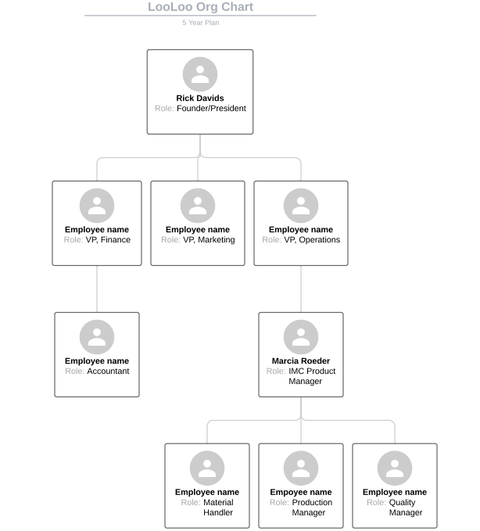

## Human Resource Budget

The human resources budget will be minimal considering the number of employees and the number of potential employees that may be hired is very small. As mentioned before, every opportunity should be taken to reduce spending if possible. Many larger companies need bigger budgets for recruitment advertising, background checks, training, travel, consultants, and even safety promotion. LooLoo will only need basic human resources, not only because of its size but also because of the fact that most of the work will be in collaboration with an established non-profit organization. An estimation of LooLoo’s human resources budget is as follows:

|  |  |  |
| --- | --- | --- |
| **Employee** | **Salary** | **Insurance** |
| Founder/President | $75,000 | $14,000 |
| VP, Finance | $60,000 | $14,000 |
| VP, Marketing | $60,000 | $14,000 |
| VP, Operations | $60,000 | $14,000 |
| Accountant | $50,000 | $14,000 |

This would result in a total annual HR budget of about $375,000. The partner organization would have their own budget for the operational side and may also provide other benefits and/or compensation to the corporate team if they are willing. For now, this is the skeleton budget estimation for human resources if the five year staffing plan goes accordingly.

# Risk Management Plan

## Potential Risks

Unfortunately there were many risks associated with this project, especially because this project focused on creating a new product for an unusual consumer market. For example, one risk is that the product is not unique and does not expand past the effectiveness of an ordinary porta potty. The teams worked to mitigate this risk by creating a unique charging and waste management capability. The focus for this project was on adding value for the customer. Figure 4 shows a risk matrix for all of the potential threats to the success of this project and product. One critical risk was the price of the components. We needed to monitor the price point at which we would be buying components in order to create a cost effective product.

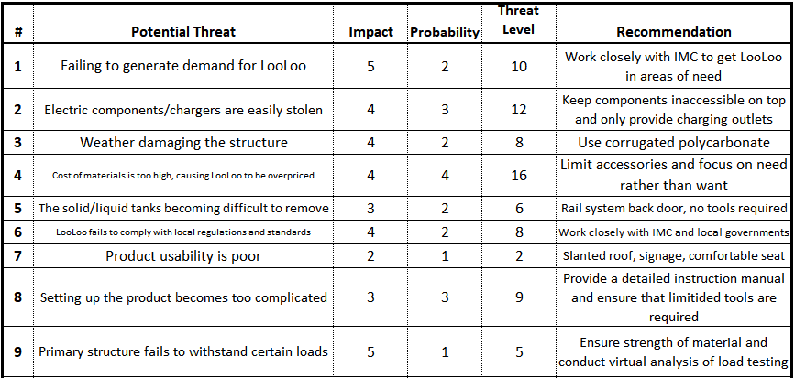

Table 4: Risk Management Table

Figure 4: Risk Matrix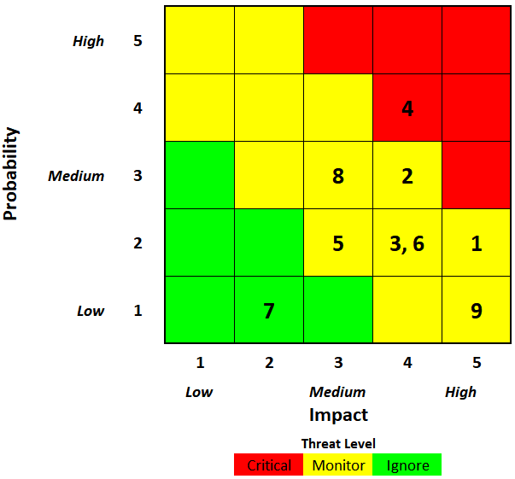

Another major risk in any project is poor communication. With this project, effective communication was absolutely crucial to project success. This was primarily because of the amount of people working on this project, 11 students and the sponsor, and also because of the nature of this project being development of an entirely new product. The teams held weekly interdisciplinary team meetings every Monday night where each team shared updates on their work that week. There was also frequent communication with the sponsor from all teams. The way the communication matrix was organized, each team had a team lead and those students were responsible for communicating with the sponsor through email and informing the rest of their team of all important information. Since these team leads were accountable for their team, that is reflected in the RACI matrix [Appendix D] for each teams’ respective activities. The rest of that team was responsible for that work and all the other project members were at least informed on their work. The sponsor was consulted on the deliverables where he had expertise and informed on everything else.

# Financials

## Financial Objectives

The objective of LooLoo’s portable toilet is to provide a distinct portable toilet that can compete well in the open market. The plan is to appeal to nonprofits, as our portable toilet aligns with many of their goals. The self sustainable additives should prove to make it appealing, and with the right pricing we should be able to sell our product to non-profit organizations, making LooLoo a profitable and well distinguished company.

## Plans for obtaining investors or strategic alliance

The MEM team was able to compose a list of nonprofits that align with our goal to provide relief in areas where needed. The plan was to send out emails and hope for a response in order to further gauge interest. Through this strategy the MEM team was able to meet with the International Medical Corps (IMC), a first response non-profit that has shown a great interest in the project and has voiced the potential of investing in LooLoo and helping to further develop the project. As well as giving insight in regards to the completed prototype, IMC can assist LooLoo with distribution. Considering the nature of their work, IMC would have the adequate knowledge needed to pinpoint places of implementation, which coincides directly with distribution.

## Pro Forma Profit & Loss statements

LooLoo intends to utilize it’s relationship with IMC in order to gain access with their manufacturing facilities. The labor would not be technically difficult and would be relatively simple and quick, especially considering the manufacturing would be partly automated. With that being said, LooLoo estimates that the labor cost per toilet would be $630. This total includes the seven people that would be working on it and the time it would take to complete (six hours). LooLoo has calculated that it’s annual costs including materials and management sum up to $40,800. Since the plan involves using IMC’s automated manufacturing facilities, an additional fixed cost will not be incurred. LooLoo plans to sell 30 portable toilets annually at a cost of $1750 per toilet, bringing a sum total of $52,500 a year. In order to break even, LooLoo would need to sell 24 toilets a year, and anything less than that puts profit margins in a negative range. Also, considering the type of product LooLoo is offering, it is not likely that this portable toilet will undergo the usual product life cycle that most products embody. With this in mind, LooLoo predicts its sales and operations will remain fairly stagnant over the course of the first five years. The total operational costs and gross profits five years to date would respectively be $204,000 and $262,500. It would take massive market fluctuations and impactful events to change this route of action. If a completely different party wanted to purchase LooLoo as a whole, that would be a simple transaction and the venture would end. If other potential sponsors/partners wanted to get in business with LooLoo, this would require the knowledge of many unknown factors, including the level of interest, magnitude of the company, and manufacturing and distribution. These are all unpredictable factors, and while LooLoo’s business model is constant and quantitative, it would be close to impossible to quantify these “what if” scenarios. While IMC is very notable and a prominent organization, LooLoo recognizes at the end of the day they are a non-profit organization and while LooLoo’s humanitarian goals align well with IMC, LooLoo in itself is not a non-profit but rather a business venture. To accommodate for our expenses, LooLoo is willing to give up 3% of gross annual income. This percentage was determined on the basis that IMC understands LooLoo is in its start up phase, and to solidify a hopefully continuous relationship as well.

## Pro Forma Cash Flow projections

Based on the total cost of operation, the gross annual profits, and the 3% of that which the IMC receives, LooLoo would walk away with $10,125. Assuming this is an ongoing venture, a percentage of this money would most likely be reinvested into marketing, research, and production efficiency. This revenue is not enough to take expansion into consideration, as this would require significant money, effort and most likely some form of partnership with an outside company. Instead the money would be focused on improving the results LooLoo has and will achieve. Possible investments include seeking ways to better production, alternative material resources, identifying different means of automation, and researching more potential customers who may benefit from this product.

## Pro Forma Balance Sheet

Total Cost Projection

Structure Total = **~$379**

Waste System Total = **~ $87**

Electrical System Total = **~$243**

**Full System Total Cost Projection = ~$710**

The cost estimates displayed above were derived from our final design review where both teams expressed their total costs but went further to relay how these numbers are completely subject to change as the main goal regarding price is to keep it under $1000.

## Alternative return scenarios

LooLoo’s product is very structured and follows a rigid procedure. With that being said the subcomponent aspect of the system can be manipulated to bring in extra revenue. The electrical and waste management system are essentially additives to a normal portable toilet. This can allow for not just sales of the toilet, but the separate components as well. LooLoo can make the electrical subsystem a product of its own for consumers and that subsystem can be broken down even further. Consumer’s can have the choice of buying the entire electrical system or just the solar panel for example. This ideology applies for the waste removal system as well. Consumers can purchase the waste removal system which would include the PVC piping so it can accommodate for most portable toilets. While this idea is out of the scope of LooLoo’s mission statement, LooLoo can provide service to private outdoor events. As is, LooLoo’s portable toilet is very technologically advanced and ahead of its time in comparison to its competitors. This service would include the delivery of each subsystem as well as the installation. A fixed fee would be incurred as well an hourly rate to accommodate for the length of the event, plusl a disposal fee for disposing the contents created within the toilet.

# Appendices

## LooLoo Virtual Model

Shown here are different views of the virtual model created in SolidWorks.

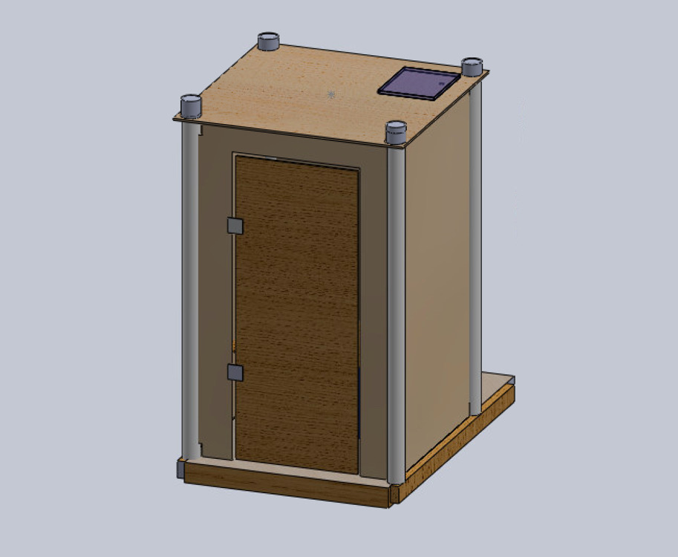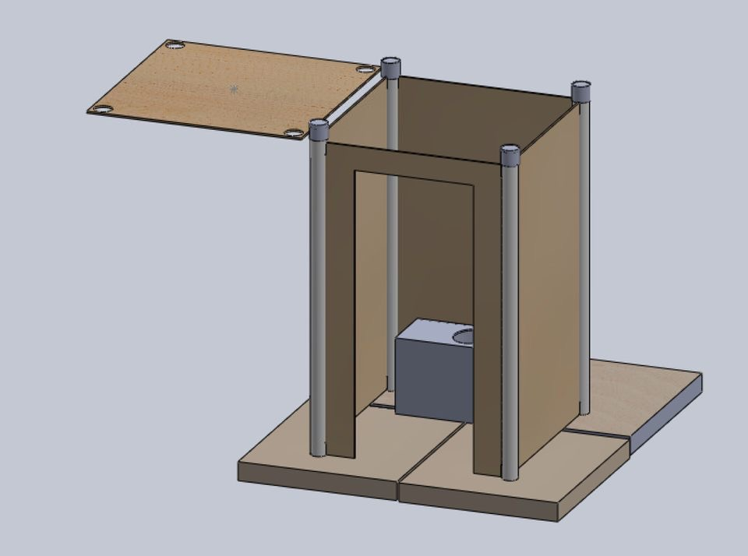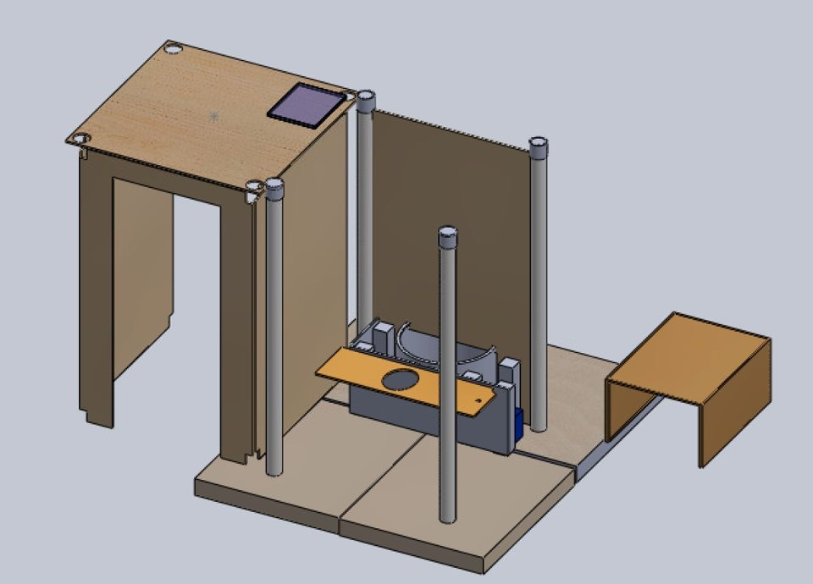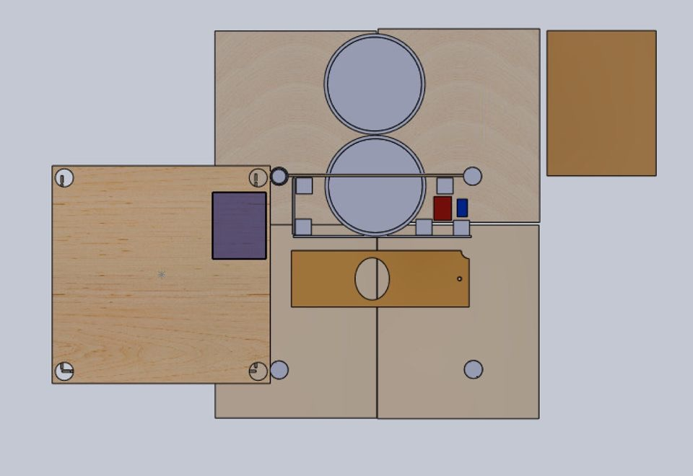

## LooLoo Full-Scale Prototype

Shown here are pictures of the full-scale model, including the structure, waste management system, and electrical components.

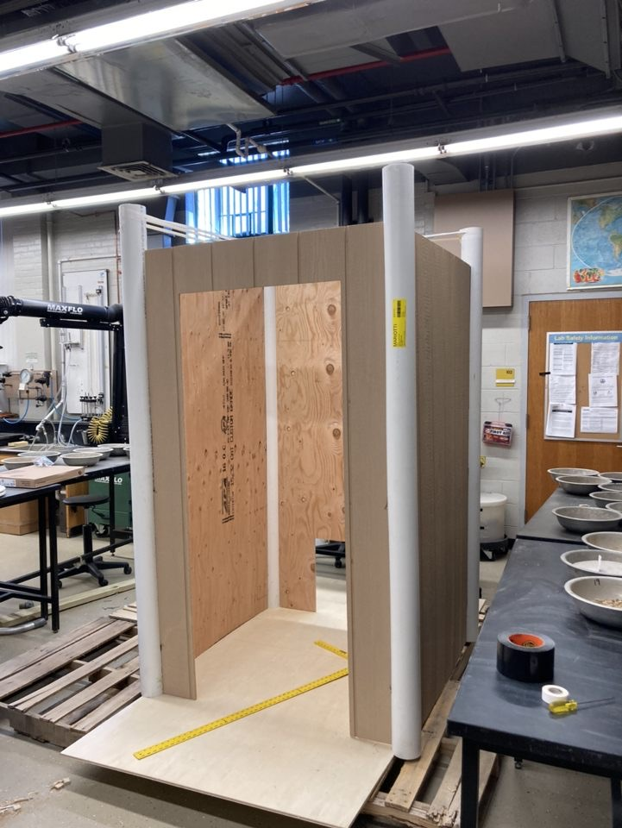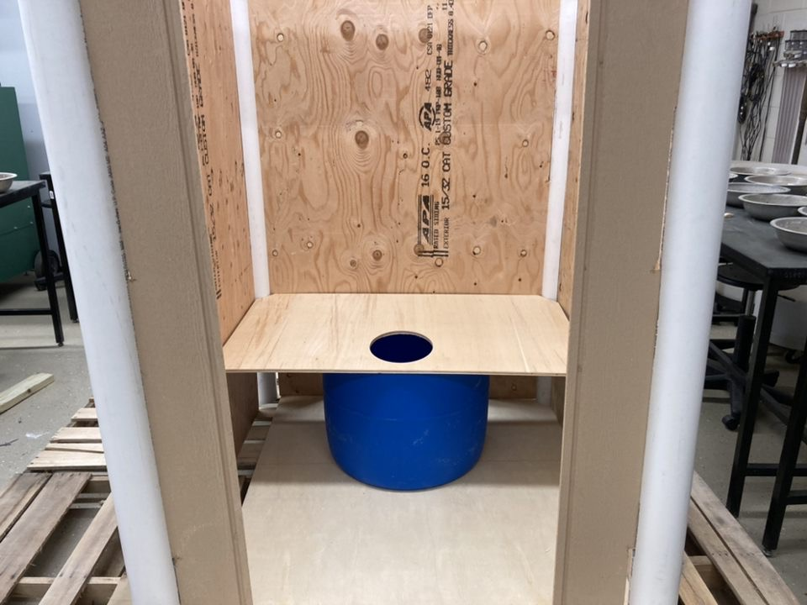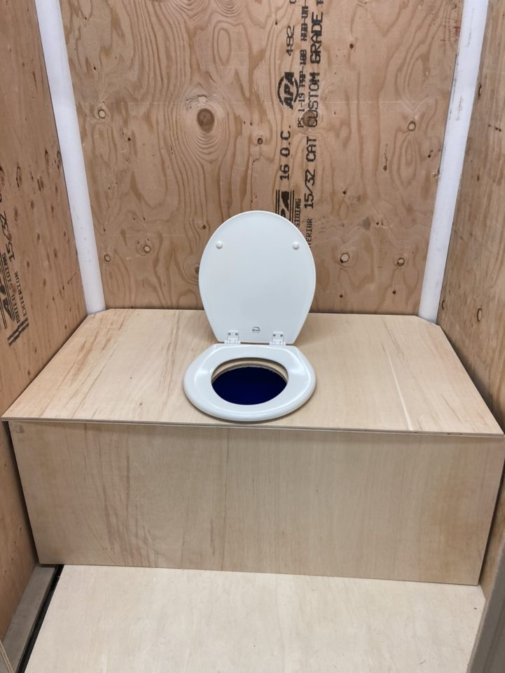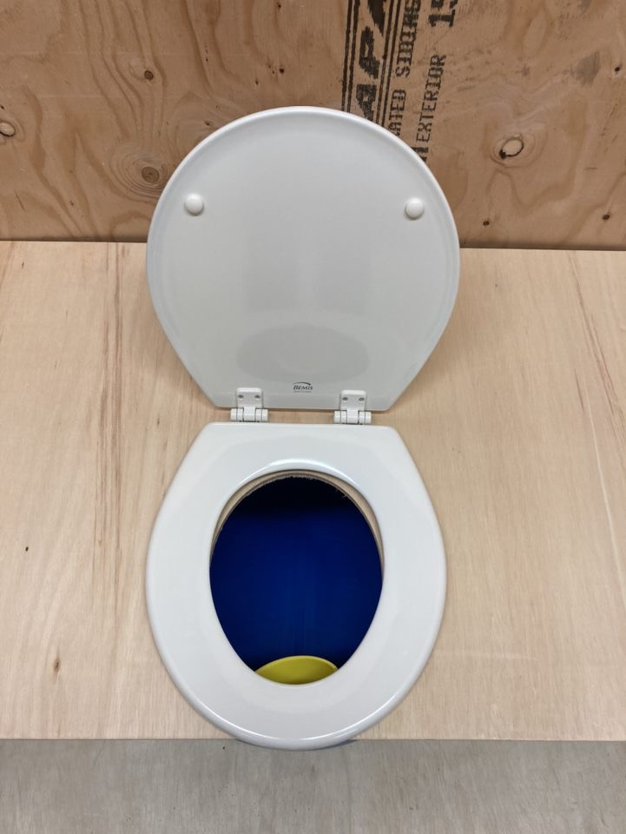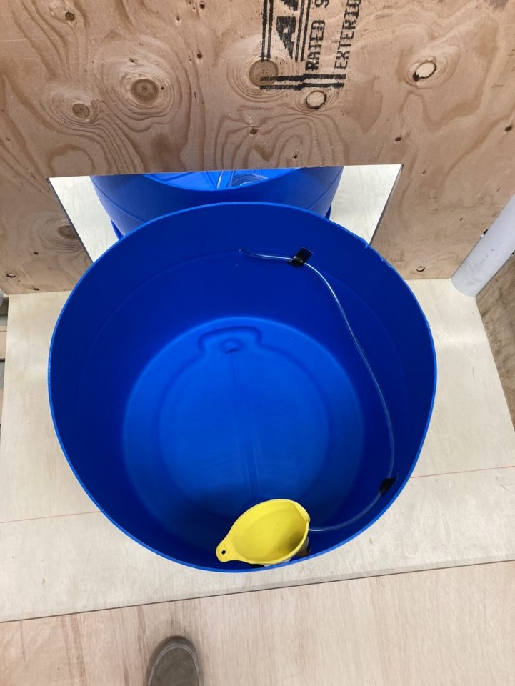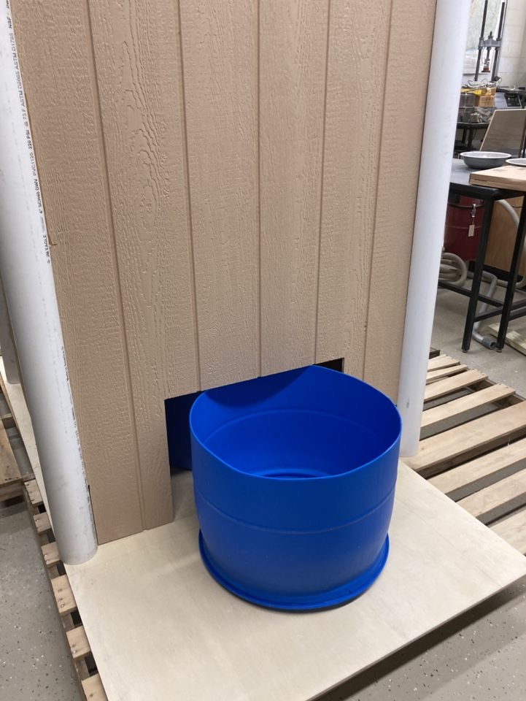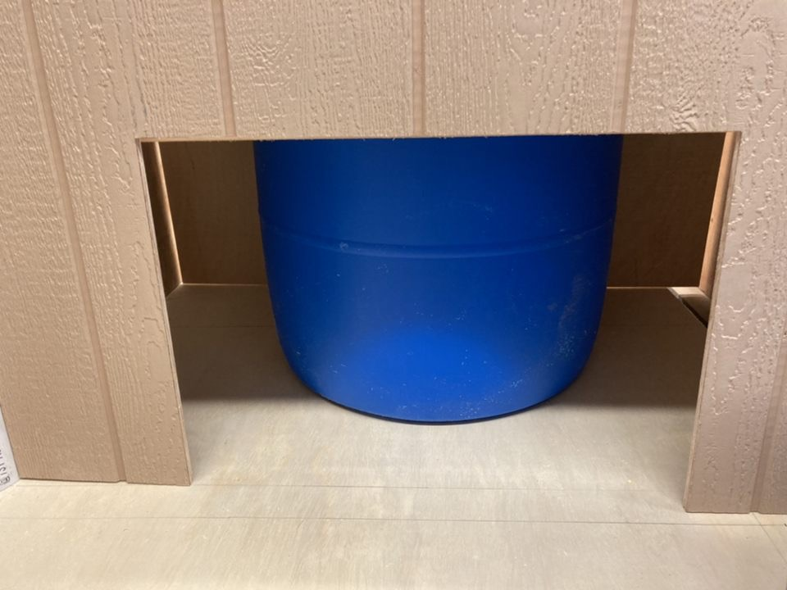

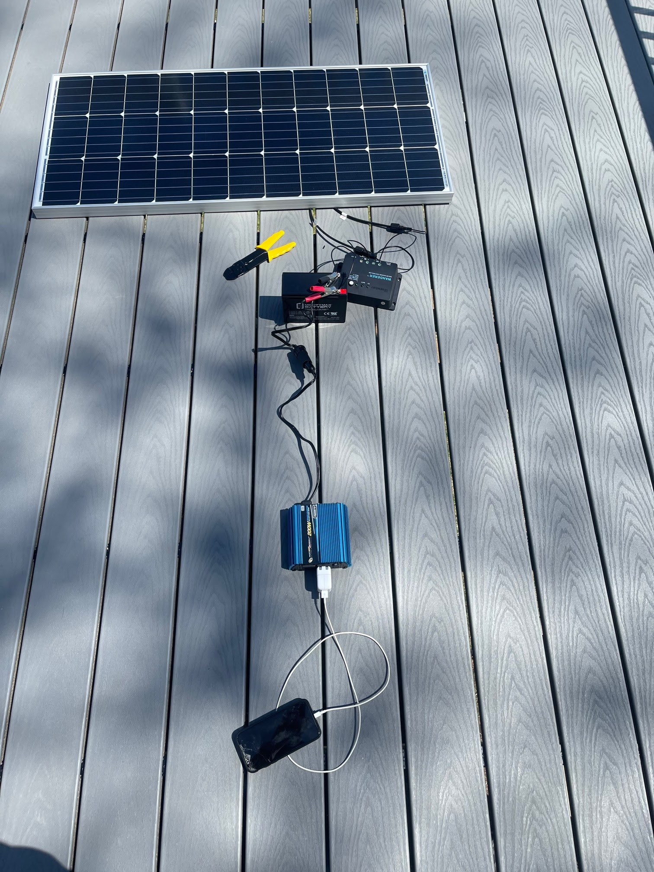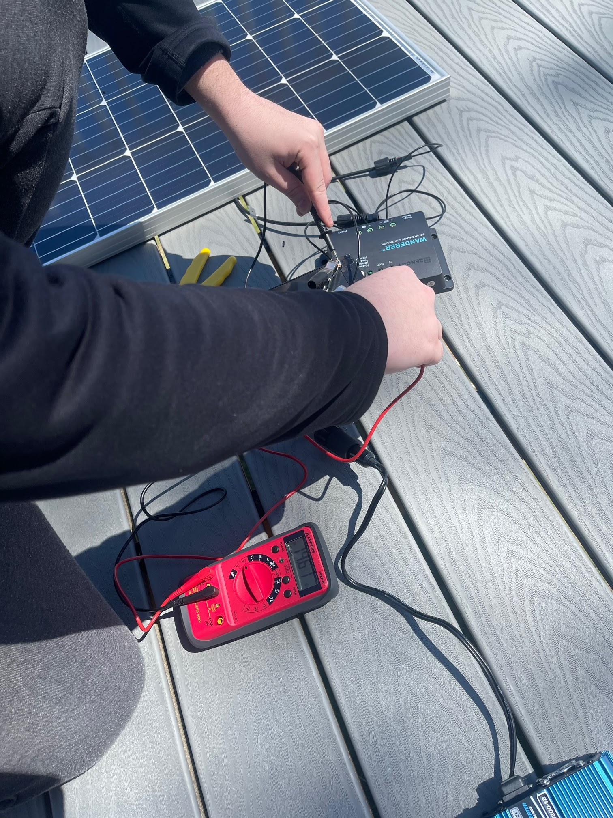

## LooLoo Instruction Manual

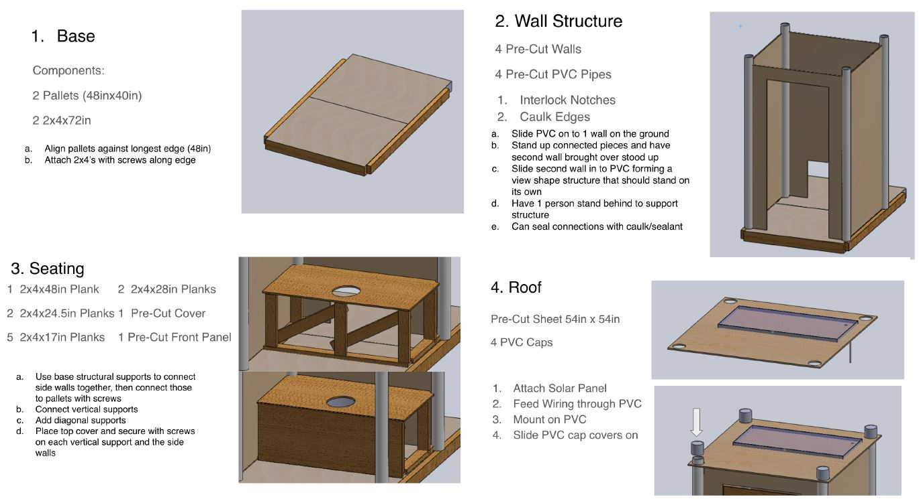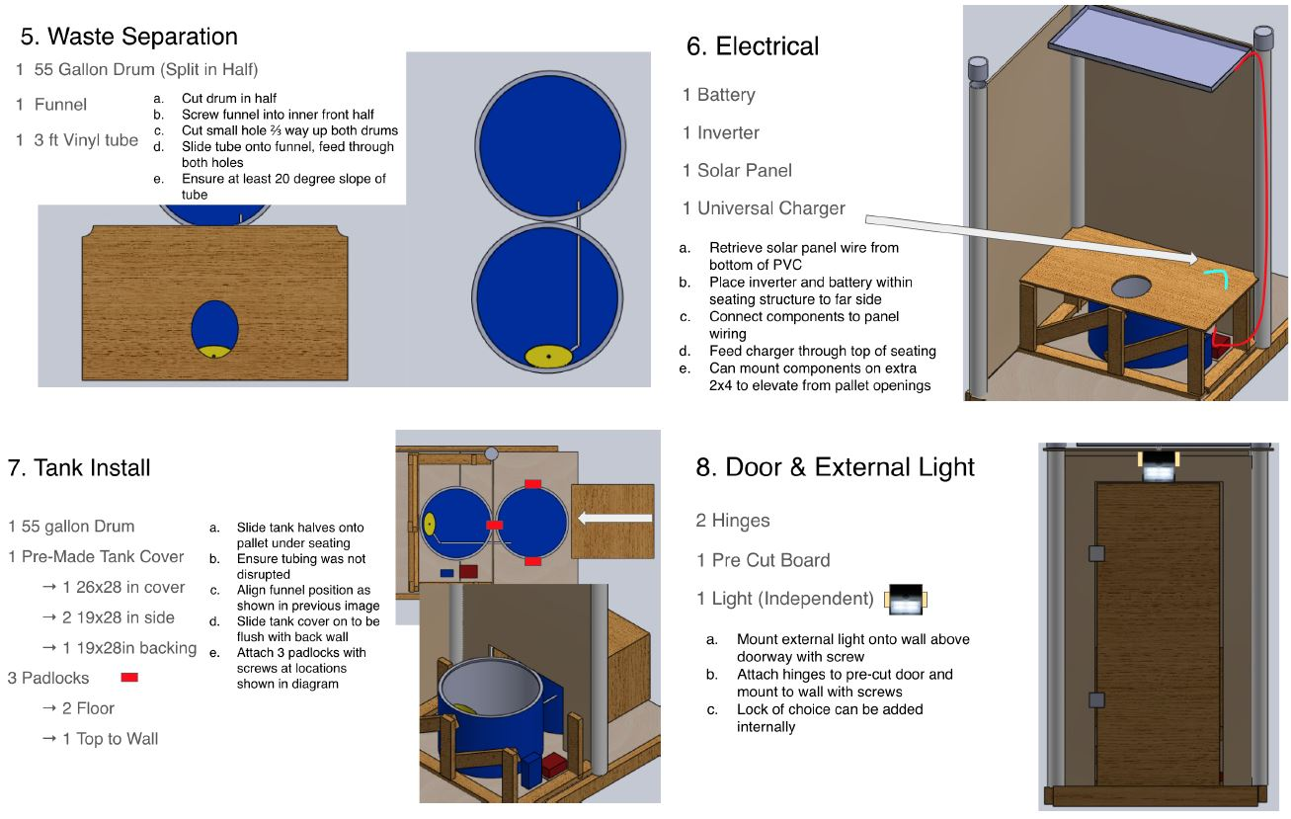

## RACI Matrix

Shown here is the RACI Matrix developed by the MEM Team for this project. It illustrates who is responsible, accountable, consulted, and informed throughout the project tasks.

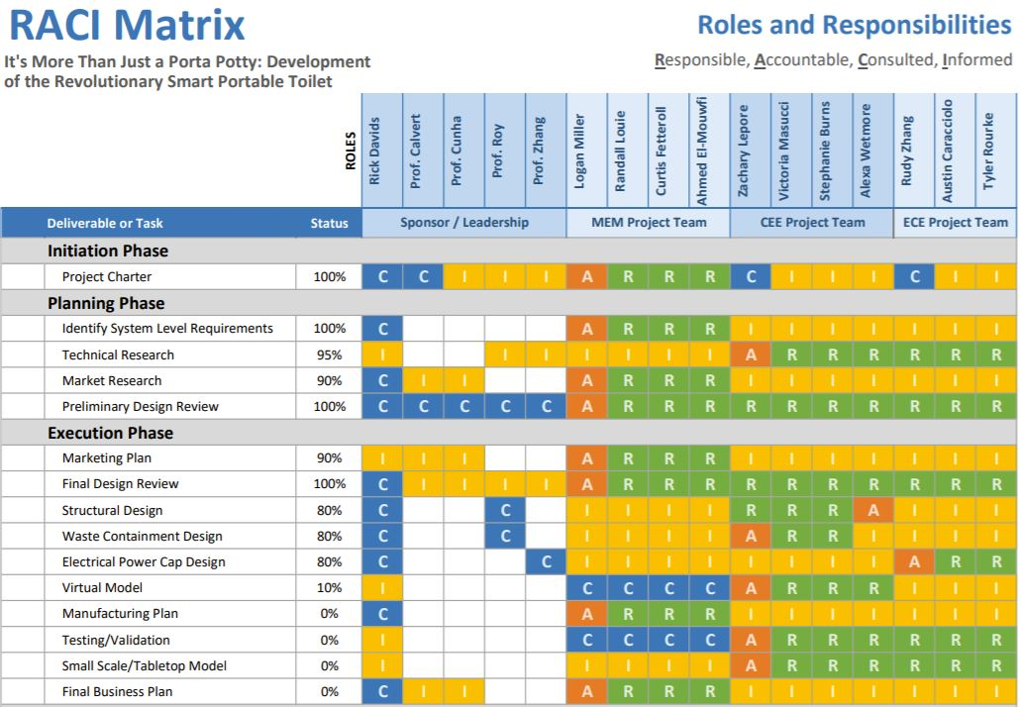

## Appendix Title

Add text or visual

# References

International Medical Corps - First there, no matter where. International Medical Corps. https://internationalmedicalcorps.org. Published 2020. Accessed December 3, 2020.

On Site. 2016. *The History And Innovations In The Porta Potty Industry | On Site Co*. [online] Available at: <https://onsiteco.com/the-history-and-future-of-porta-potties/> [Accessed 16 December 2020].

Portable Toilet Rental Market Size, Share | Industry Report, 2019-2025. Grandviewresearch.com. https://www.grandviewresearch.com/industry-analysis/portable-toilet-rental-market. Published 2020. Accessed December 8, 2020.

Tblustar.com. 2020. *Starting A Portable Toilet Business Tips | T BLUSTAR*. [online] Available at: <https://www.tblustar.com/starting-a-portable-toilet-business-tips/> [Accessed 16 December 2020].